**Full Stack Development with MERN**

**Database Design and Development Report**

|  |  |
| --- | --- |
| **Date** | **18 July 2024** |
| **Team ID** | **SWTID1720077433** |
| **Project Name** | **Grocery App** |
| **Maximum Marks** |  |

**Project Title: All-Mart Grocery App**

Date: 19/07/2024

Prepared by: Mohammed Zaid, Naveen R, Mohammed Faisal

**Objective**

The objective of this report is to outline the database design and implementation details for the **All-Mart Grocery App**] project, including schema design and database management system (DBMS) integration.

**Technologies Used**

* **Database Management System (DBMS):** MongoDB
* **Object-Document Mapper (ODM):** Mongoose

**Design the Database Schema**

The database schema is designed to accommodate the following entities and relationships:

**Implement the Database using MongoDB**

The MongoDB database is implemented with the following collections and structures:

Database Name: test

1. Collection: foods

- Schema:

```

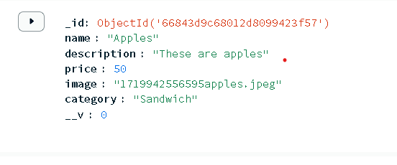 ```

2. Collection: orders

- Schema:

```

```

3. Collection: Users

- Schema:

```

{

}

```

**Integration with Backend**

* Database connection:
* A computer screen shot of a computer error

  Description automatically generated
* The backend APIs interact with MongoDB using Mongoose ODM Key interactions include:
  + User Management: CRUD operations for users.
  + Post Management: CRUD operations for posts, with user authentication.
  + Comment Management: CRUD operations for comments associated with posts.